**Problem No. 1**

**BCD to Seven Segment Decoder** Boolean equations is given below. Implement this circuit on Logic works

Using 3x8 Decoders, Logic gates and LEDs. For input use hex keyboard.

**Boolean Equations:**

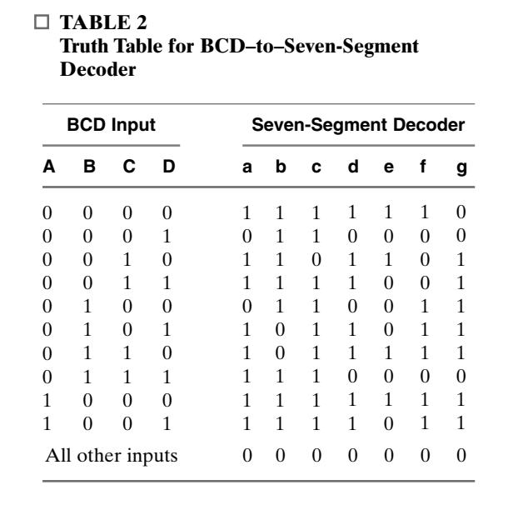 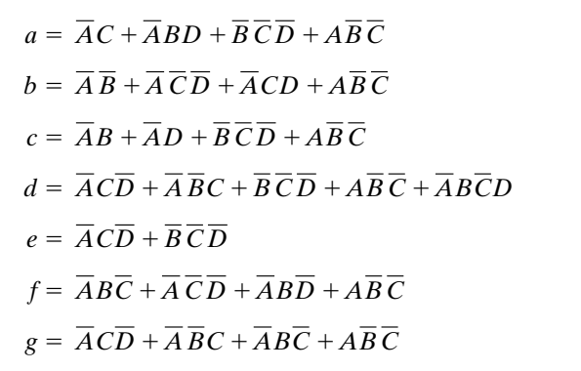

**Note: Submit Logic works file on Google Classroom. Make sure you submitted correct file, corrupted or empty file will be awarded zero.**